Aerosmith Maze

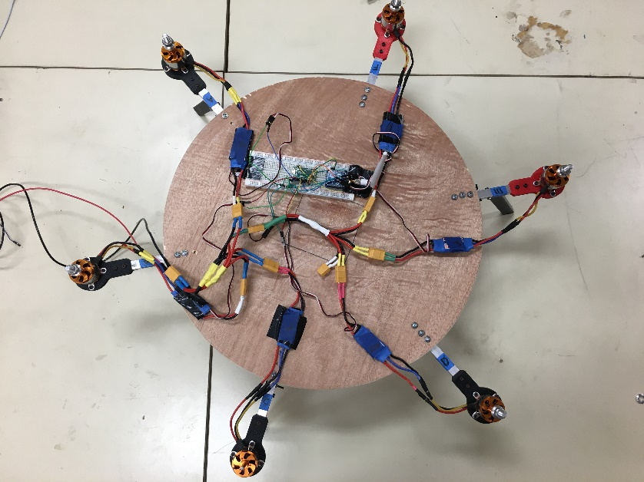Diameter: 48 cm

Thickness: 1.2 cm

Materials

1 Round piece of wood

6 Turnigy Aerodrives motors (D3536/9 910KV)

6 Electronic Speed controllers (Hobby King 30A UBEC)

1 power supply (BK precision 1900)

Dowel Holder

Inner Diameter: 1cm

Height: 3.6cm

Lower Width: 1cm

Upper Width: 1.5 cm



Sensor Boxes

Length: 8.5 cm

Width: 7.4 cm

Height: 7.5 cm